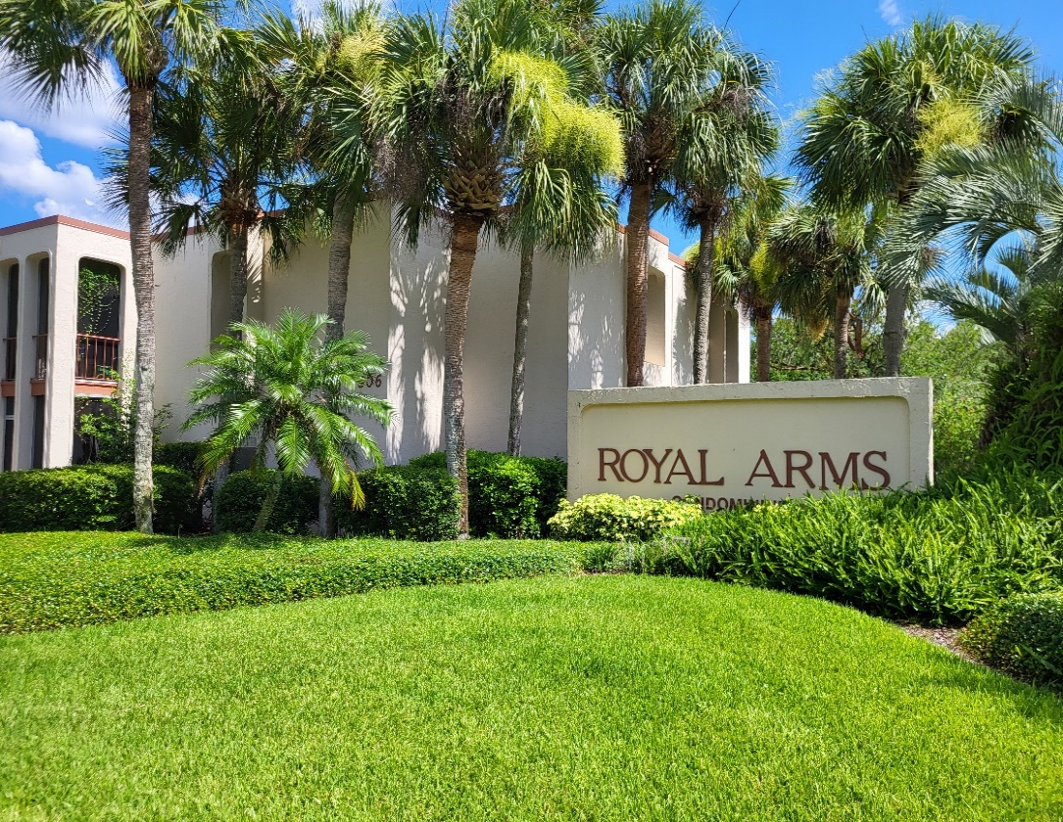


Royal Arms Condominium Association, Inc.
JULY 2025 NEWSLETTER



Board of Directors

Board President: David Wheaton
Treasurer: Frank Paul Barber
Secretary: June Williams
Board Members: Elwood ‘JR’ Williams and Efrain Valentin-Aviles

Administrative Assistant: Rosemarie Kavanagh

Maintenance Techs:
Harold (aka Bill) Hopper
Ty Weitzel
Patrick Jones

Website: http://www.royalarmscondos.com
Email: admin@royalarmscondos.com

AFTER HOURS EMERGENCIES:
For ALL After Hours Emergencies please call the
Answering Service on (407) 992-6536

EMERGENCIAS FUERA DEL HORARIO DE ATENCIÓN:
Para TODAS las emergencias fuera del horario
de atención, llame al
Servicio de contestador al (407) 992-6536

EMERGENCY CONTACTS: Please update your mailing and contact details with Vista at: www.Vistacamfl.com Homeowner Portal: https://portal.vistacamfl.com/

Royal Arms Condominium Association, Inc.

Pool Rules and Usage
As Summer approaches the Pools are being use more frequently. We ask all Residents to adhere to the Pool Rules and to be respectful of other residents who are using the pools. We have three pools on the Property and all pools can be used by our Residents. Pool #1 is located on the Southside of the Office; Pool #2 is located on the Southside of building #518 and northside of building #522; Pool #3 is located at the rear of the Property on the Eastside of building #548. Pool Key can be purchased at the Front Office for a fee of $20. Only cash accepted! Your pool key will give you access to all three pools as well as the laundry rooms on the Property.
Rental of Units/Tenants
Homeowners are reminded that it is your responsibility to carry out the required background check and credit check for new tenant(s). It is essential that a copy of the signed Lease Agreement including the Background Check that was done be sent to the Front Office prior to your tenant(s) move in date.
Furthermore, it is the Owners’ responsibility to let the Office have in writing the name(s) of the individual(s) who will be living in the unit, the number of occupants, contact details and their vehicle information.
Homeowners are further reminded, as per the Association’s Rules and Regulations and By-Laws, units are to be rented for twelve (12) month intervals and MUST NOT be rented on a short-term lease or on a month-to-month basis or used as an Air B&B.
JULY 2025 NEWSLETTER
Upcoming Local Events in JULY!

April brings a mix of celebrations, including April Fool's Day, Easter, Passover, Earth Day, Autism Awareness Month, and various national and international days, as well as Black Women's History Month and National Arab American Heritage Month
.
July 3rd 2025: RED HOT & BOOM Music & Art Festival (See Poster below). This is a popular event so get your tickets early.


